

**Individual Assignment Cover Sheet**

*You must keep a photocopy or electronic copy of your assignment.*

|  |  |  |  |  |
| --- | --- | --- | --- | --- |
| Unit name: | Front-end Web Design | | | |
| Unit code: | 11056 | | | |
| Semester: | 1 | | Year: | 2019 |
| Tutor’s Name: | Riley Post | | | |
| Tutorial Day and Time: | Tuesday 8:30am | | | |
| Assignment Name/Number: | | Assignment 3 - Rationale | | |
| Case Study Name and Number: | | Front-end Website | | |

**I declare that this assignment is solely my own work, except where due acknowledgements are made. I acknowledge that the assessor of this assignment may provide a copy of this assignment to another member of the University, and/or to a plagiarism checking service whilst assessing this assignment. I have read and understood the University Policies in respect of Student Academic Honesty.**

|  |  |  |  |  |  |  |  |  |
| --- | --- | --- | --- | --- | --- | --- | --- | --- |
| Student ID: | u | 3 | 1 | 6 | 1 | 7 | 3 | 4 |

Signed: ______N.Villiers______________________Date:_________17/05/2019__________

Responsive web-site rationale

Including accessibility audit

Contents

Assignment Name/Number: 1

Assignment 3 - Rationale 1

Case Study Name and Number: 1

Rationale 3

Background 3

Evolution of the design 3

Paper wireframe 1 3

Paper wireframe 2 5

Adobe XD digital wireframes 6

Final build 7

Design process 9

Building the Website 10

Challenges faced 11

Solutions to challenges 11

Site influence or inspiration 12

Second site for inspiration 13

Third site for inspiration 14

Research performed 15

Colour schemes 15

Fonts 16

Accessibility issues or usability issues 17

How were they resolved? 18

Summary 19

# Rationale

## Background

For this assignment, I have been required to create a website which demonstrates the skills, which I have acquired, throughout the duration of the whole Front-End web Design course. I am required to show that I am able to utilise the skills which I have developed from modules 1, 2 and 3. The requirements of this assignment are that I construct a web site that is responsive, accessible and usable, as well as creating a Rationale and performing an accessibility audit.

## Evolution of the design

The very first part of designing the website, was when I created wireframes to show the basic layout and the responsive transitions used in the mobile, tablet and desktop viewports. You can see these below.

### Paper wireframe 1

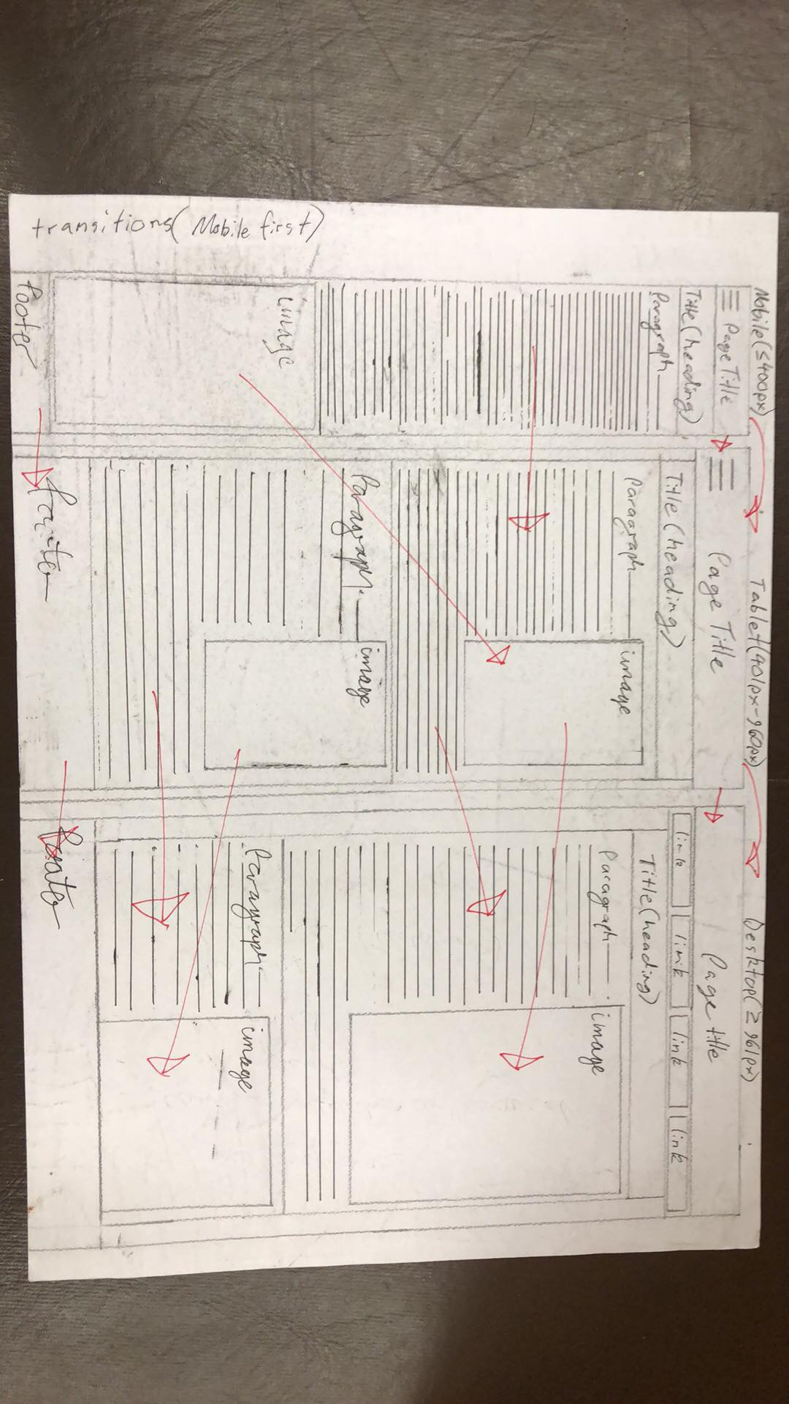You can see from this wireframe that all of the elements have been maintained, but somewhat rearranged when transitioning from the mobile to the tablet view, and from the tablet view to the desktop. I have used a mobile first responsive design, which means that the default CSS selectors are relevant to the mobile sized viewport and that when a tablet or desktop sized display is utilised, their own CSS selectors are used, using media queries. This was my original wireframe which I drew. I later decided that it was not ideal to have a single column layout and so began to research some other responsive layouts, which could rearrange the content in different viewports. I decided, after looking at multiple other responsive websites, that it would be better to use a design which uses a three-column layout, as you can see in the next wireframe, which I have drawn. You will notice that in the mobile viewport site, that there is a single column, where every section is displayed under the previous one. When you look at the tablet sized viewport, you will notice that the carousel takes 100% of the width of the body, but paragraph 1, 2, 3 and 4 are only 50% of the width of the page body, so that they can be displayed in two columns, next to each other. Finally, the footer is consistently 100% width throughout all three viewports.

## Evolution of the design, continued…

In the desktop viewport site, you will notice that a three colunmn approach has been implemented. In this viewport, the content has been rearranged, so that paragraph sections are all above the carousel section. In both the mobile and tablet viewports you can see that a “hamburger menu” has been used alongside the Norfolk Island Logo, which are both nested within the “<nav>” section. In the desktop viewport however, it was drawn so that logo is to the left of four menu items, which would include the link’s text and an image.

I have drawn arrows on the page in red pen, to show how each section transitions when the viewport is changed. You will note that there is a dotted line shown toward the bottom of the wireframe, this is to indicate that some content has not been shown, so that the layout of the page can be shown within the confines of the page. This is called “below the line”.

### Paper wireframe 2

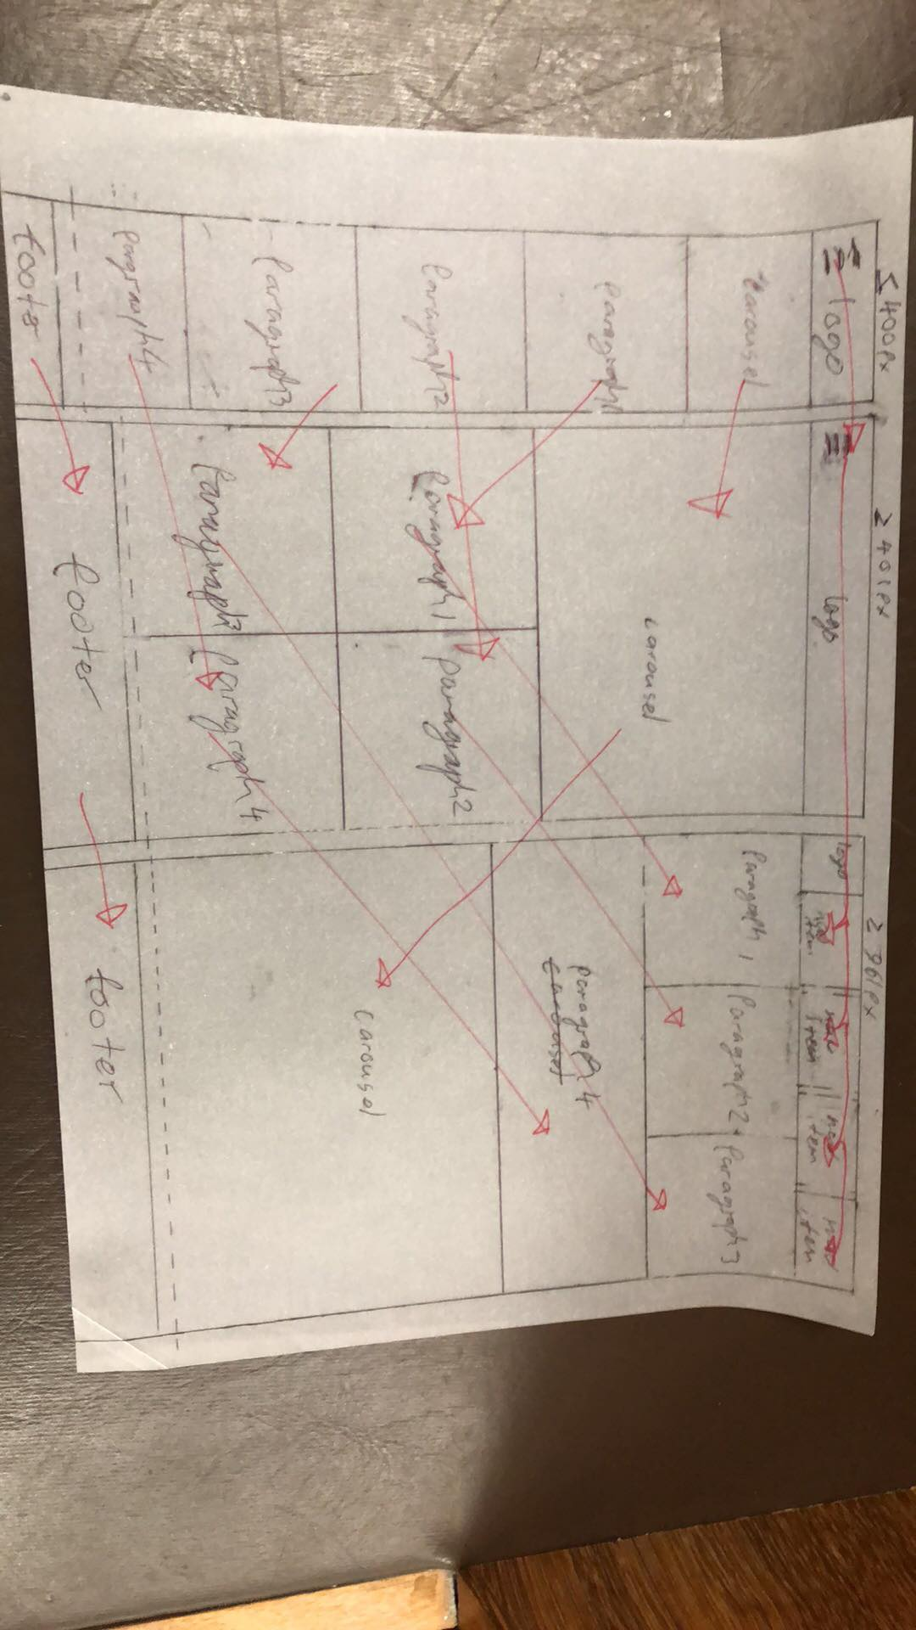

### Adobe XD digital wireframes

After these paper wireframes were drawn, I recreated these digitally, using “Adobe XD”. These can be seen on the following page. You will note that these follow the same basic layout, but with color and more styling apparent. You will likely note also that the logo on the desktop was moved to the center, to be in bewteen the menu links, rather than being to the left of them.

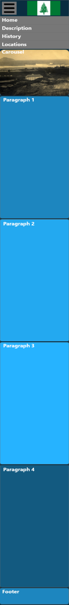 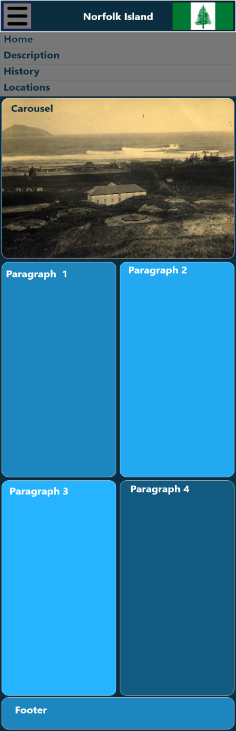 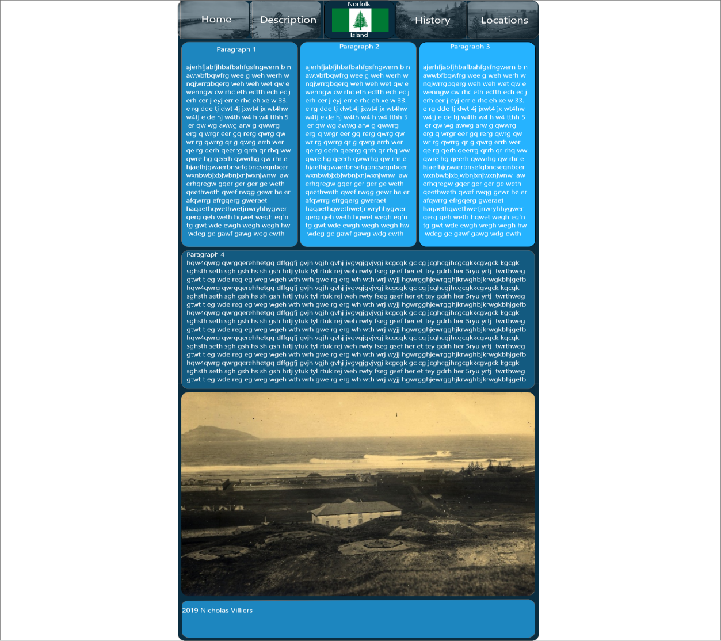

### Final build

After these wireframes were created, I proceeded to build the website, but in this process, the design had changed yet again. After testing the website for accessibility, useability, reponsiveness and overall aesthetics, I finished with a design, which looks like the screenshot below. The final design has some resemblence still, to both the paper wireframes and the Adobe XD ones, but with a few changes. Nonetheless, the layout and responsive transitions have remained. Due to the nature of the images relevant to the website, where they have widely varying aspect ratios and resolutions, I have decided against using a carousel and have instead, replaced this section with an additional “feature”, which consists of images and text, with the image being 100% of width of the page. This being the case, there now exists 5 “feature” sections in the layout, instead of 4, as was originally planned. You can see the desktop view, driectly below. You will note that I have decided to include links to social media in the-top right corner of the navigation menu.

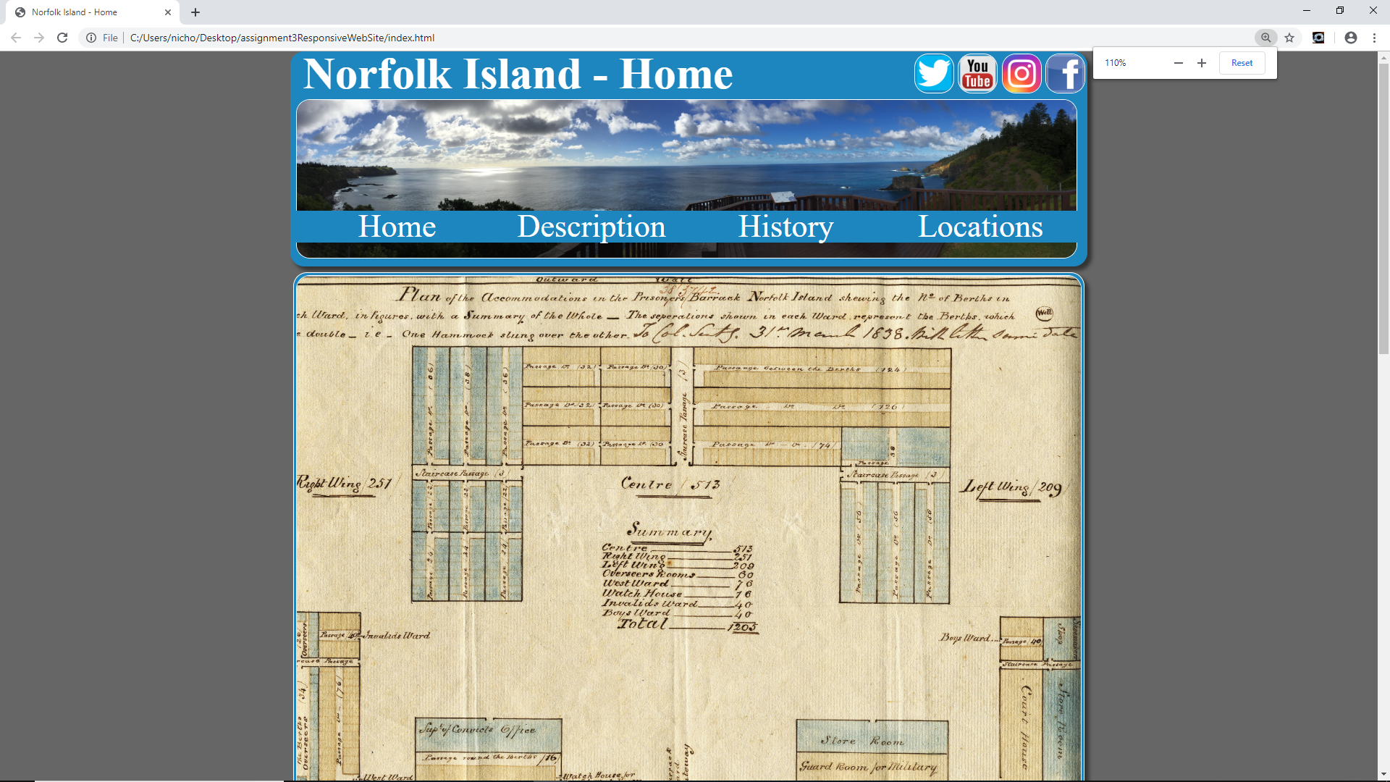

### Final Build, continued…

Below you can see both the final tablet view of the website as well as the mobile, with the hamburger menu replacing the desktop naviagtion menu. You can see that the image on the left is of the mobile view and has a single column layout, whilst the one on the right is the tablet view and has a two column layout. You will notice that the social media links have been omitted. This is to prevent too much information being presented on a smaller screen and defeating the purpose of having a reponsive design. The social media links have only been included for display on the desktop view, where screen space is less scarce. I have shown below how the website appears in the mobile and tablet view.

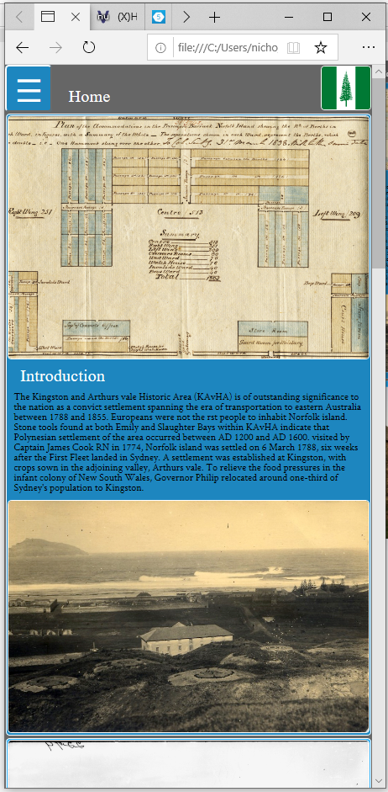 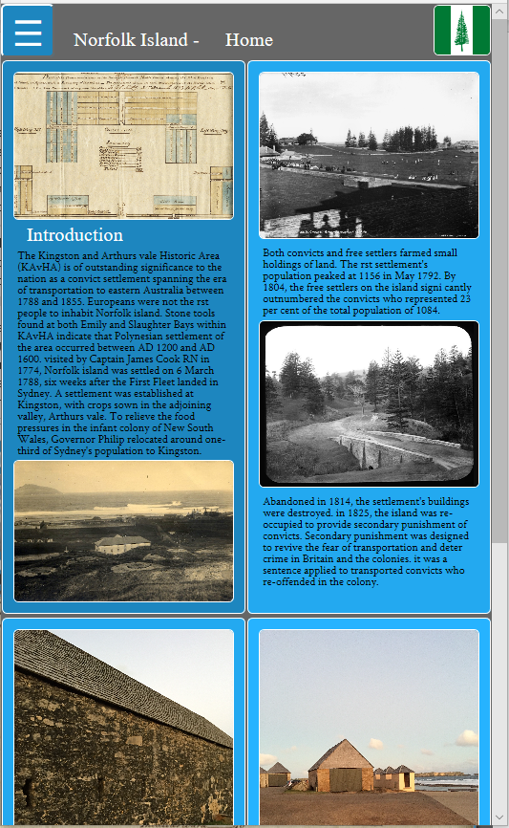

## Design process

As mentioned above, the design process involved creating multiple wireframes, to be used to base my responsive layout upon and also the transitions between different layouts, dependant on the viewport. After these paper wireframes were created, I sought advice from Riley, my tutor, before progressing further. He suggested things like considering a slideshow or carousel, setting scroll speed, using a CSS grid, using a flexbox, using Adobe XD to create some digital wireframes, considering more creative or contemporary navigation menu options, finding alternate fonts, alternating the layout of images nested within paragraphs, and determining the placement of content in which sections. Taking on board this information, I proceeded to create yet another paper wireframe which addressed these issues, where relevant. After I was happy with my new wireframe and the layout, I continue to get set up in Adobe XD, and begun building some digital wireframes. You can see below an image which shows the three digital wireframes I created, compared side-by-side. You can see that I have attached labels at the bottom of each view to show the calculated pixel area of each view. The number of pixels used by each design, doesn’t differ too drastically, which I believe, shows that the screen space has been used fairly efficiently. You can see that most of the major content is still included, so that the user may still enjoy the functionality of the website, without too much compromise.

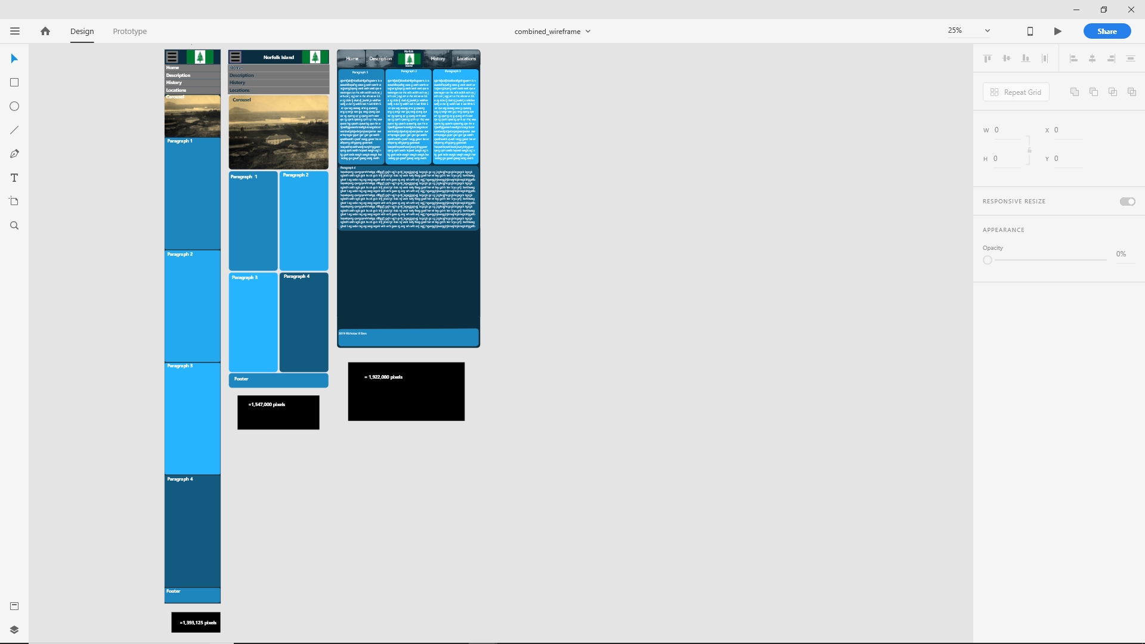

### Building the Website

After I had planned out the layout and design of thee website, I begun to create the website in “Brackets”. I began by creating on basic HTML page and then adding the sections outlined in the wireframe. At this point, the sections did not contain any content but were used to merely set the appearance of the website.

I then started to code the navigation menu, which proved to be difficult. I followed a basic unordered list style navigation, as was taught in the course modules.

After this I begun to create the stylesheet, media queries and properties of the elements in different viewports. The page now had a basic structure and looked somewhat like I had planned, in each viewport size.

The next stage was to add all of the paragraphs, headings, and images. The website now contained all of the content which it needed, and I began to tweak the stylesheets to achieve the desired looks and responsiveness.

After this, I performed usability and accessibility testing to ensure compliance, and some changes had to be made, which ultimately changed the overall look of the website somewhat.

## Challenges faced

As mentioned, there were some minor issued faced, where the layout has been changed slightly, after the initial planning and drawing the wireframes. This can primarily be attributed to accessibility issues, which have been explored further, later in this document.

Apart from this I had experienced some difficulty when implementing the two separate navigation menus which the site uses. In the desktop view, the desktop menu is displayed, which is significantly larger than the mobile/tablet view menu. The tablet/mobile view menu is a “hamburger menu”, which means that when it is not expanded, all that is visible is a symbol which has 3 small parallel lines on a button. This button is used to expand the hamburger menu, so that it becomes visible and usable. This is very helpful in reducing the amount of space that is used, in the mobile and tablet responsive designs.

## Solutions to challenges

To combat accessibility issues, which were mainly based around contrast ratios, and missing headings, I performed accessibility testing and reconfigured the colours used in both the fonts and the background colours of the sections, to ensure that they met the accessibility standard of a 4.5:1 contrast ratio. The tool I used to do this can be found at <https://webaim.org/resources/contrastchecker/>. To combat the issue of headings missing headings, I simply added “<h2>” headings at the beginning of each new section, so that when using a screen reader or other assistive technologies it is easier to navigate the site. Without headings this type of navigation would prove very difficult.

To successfully implement both the desktop and the laptop/mobile navigation menus, I eventually decided it was best to maintain both menus within the layout, but with only one visible at any given time. The way in which I achieved this, was by creating two menus with two classes, one being “class=”DESKTOP”, the other being “class=” LPTPMBL”. When the website is displayed on a display which is 1000 pixels or less, in width, the “LPTMBL” navigation menu becomes visible and when the display is more than 1000 pixels, in width, the “DESKTOP” navigation menu becomes visible. Because I have used a mobile first design, the “LPTMBL” navigation menu is visible by default and the “DESKTOP” navigation menu is set to be hidden. Both navigation menus coexist on the website, however only one is visible at any given time.

## Site influence or inspiration

As part of the process of developing a responsive website, I have researched several different websites, which have made use of responsive design.

I found the following website and have decided to use similar styling with my website, as it is responsive and uses a combination of images and other content, as my website will. It also makes use of a hamburger menu, similar to mine. <https://www.totaste.co/>

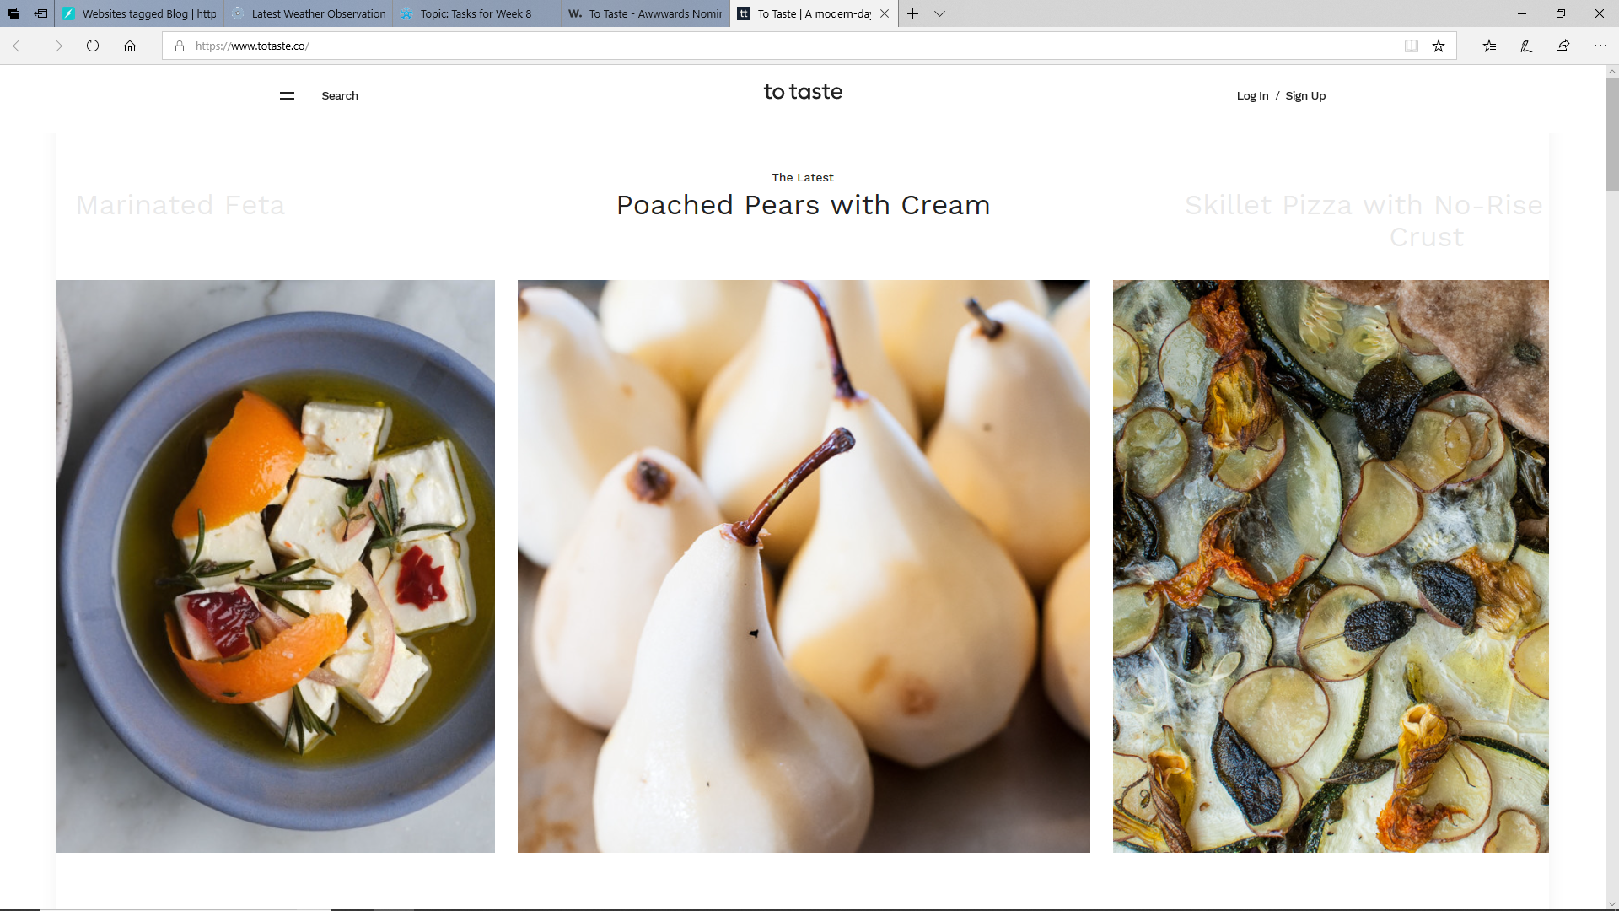

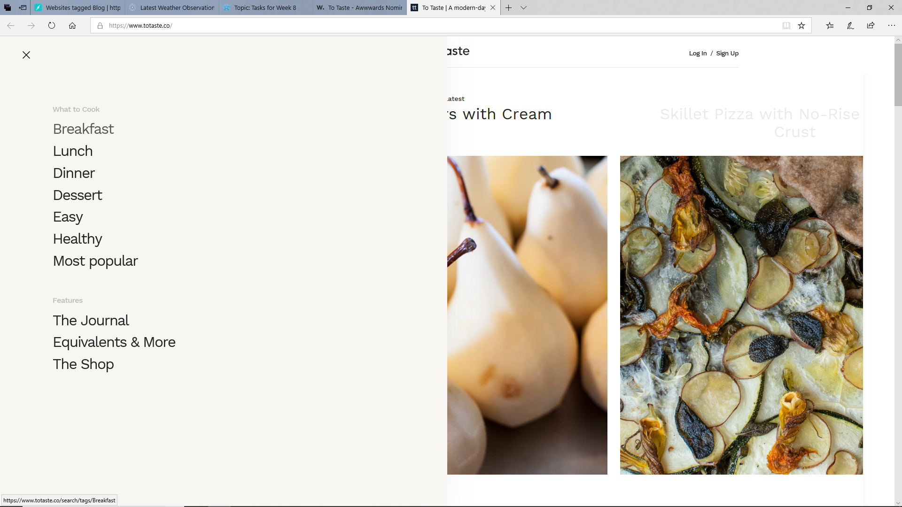

### Second site for inspiration

It was suggested by Riley in the week 9 tutorial, that I seek inspiration for a more creative nav menu, and so I began to research some alternative methods for navigation menus. The sites I look at with these are depicted below. I particularly liked the website listed in the link below called” Plug and play” and have decided to try and create something similar wherein there is a “carousel” at the top and the menu appears directly below this, but with the exception that this is just one single image rather than an entire carousel.

<https://www.sitepoint.com/20-standout-navigation-menu-designs/>

The website appears like this image here.

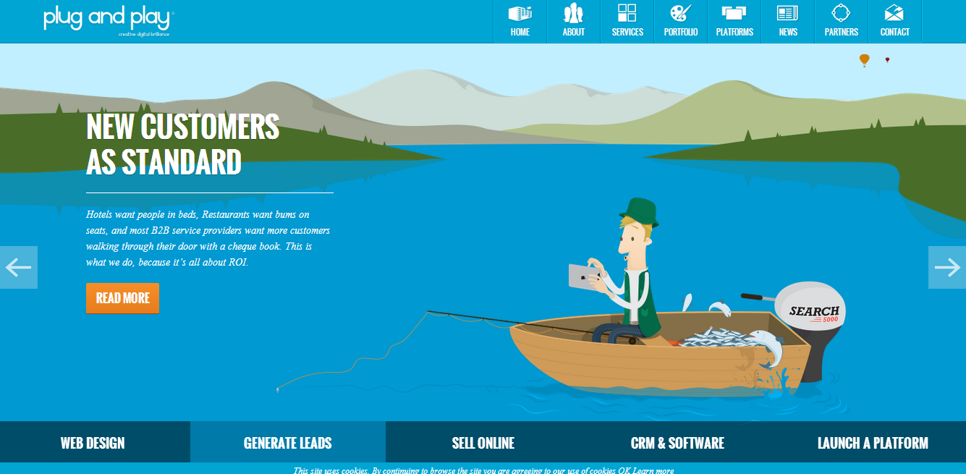

I have used the main image in the navigation area with social media links above it and the main page links below it, similar to what was achieved with he “plug and play” website.

### Third site for inspiration

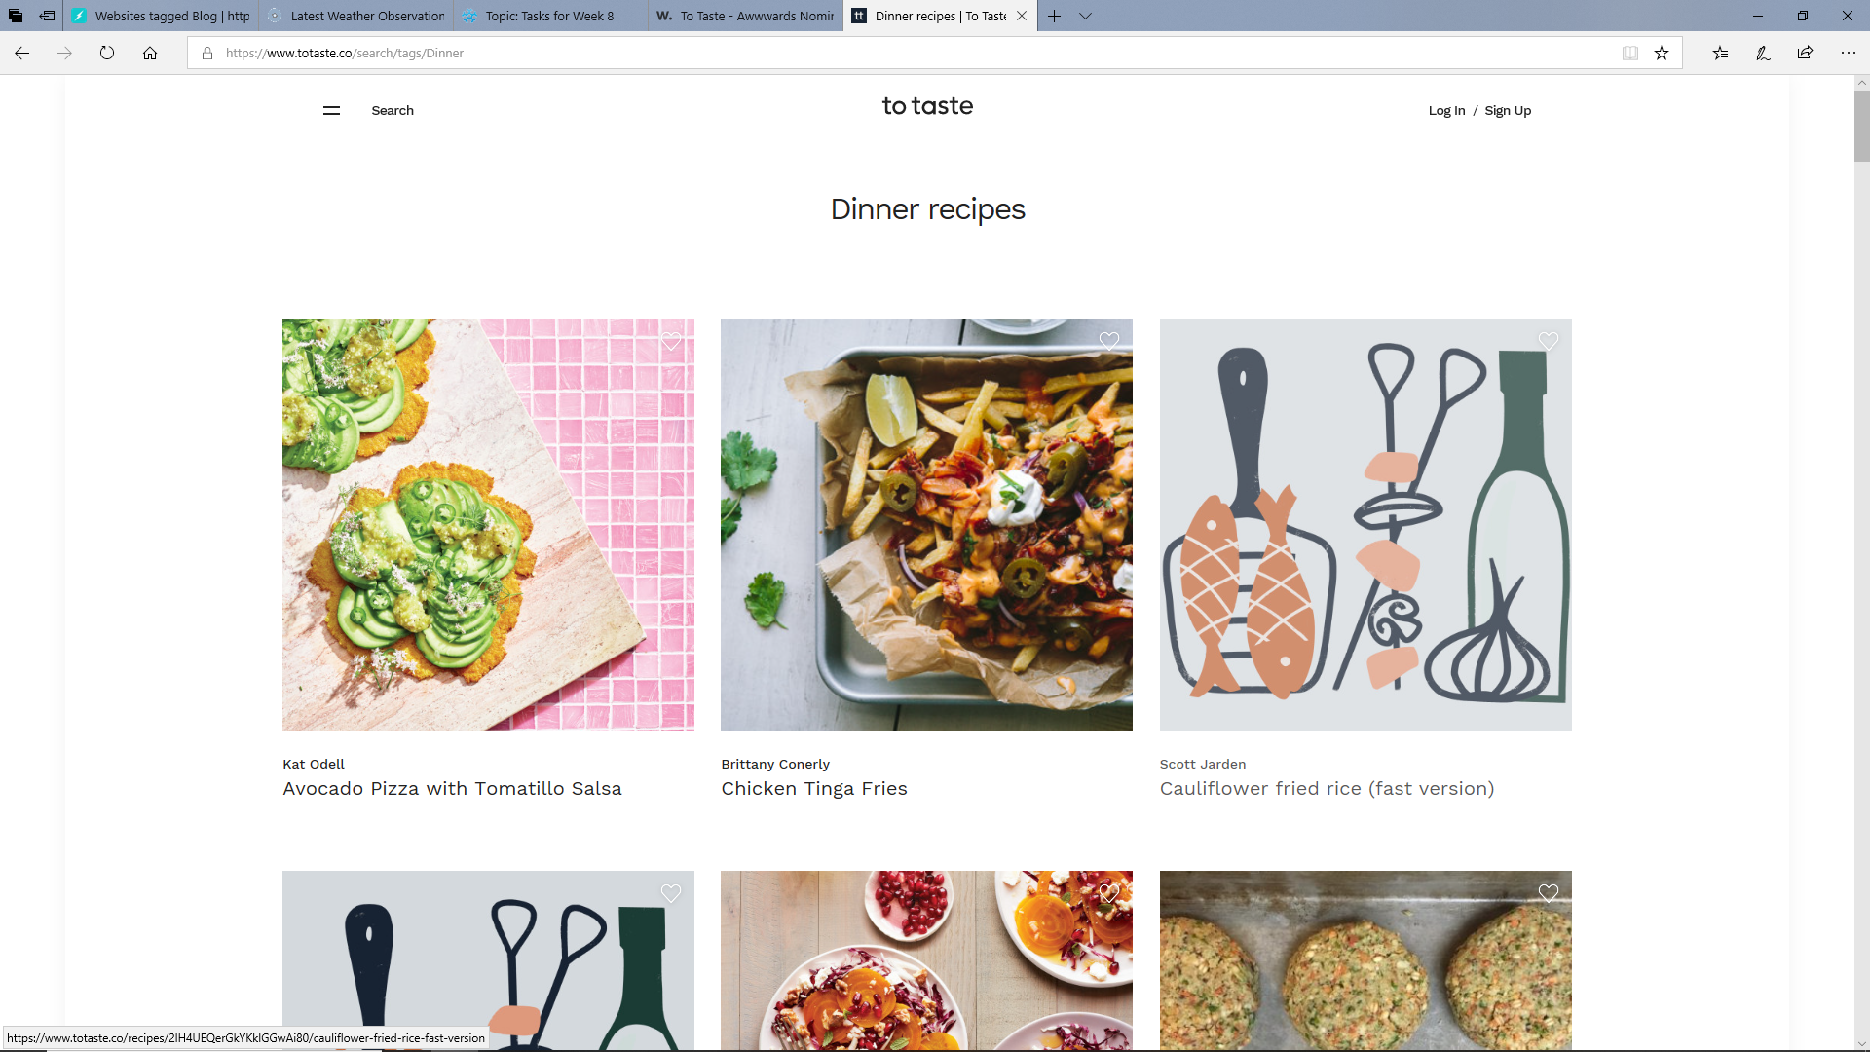

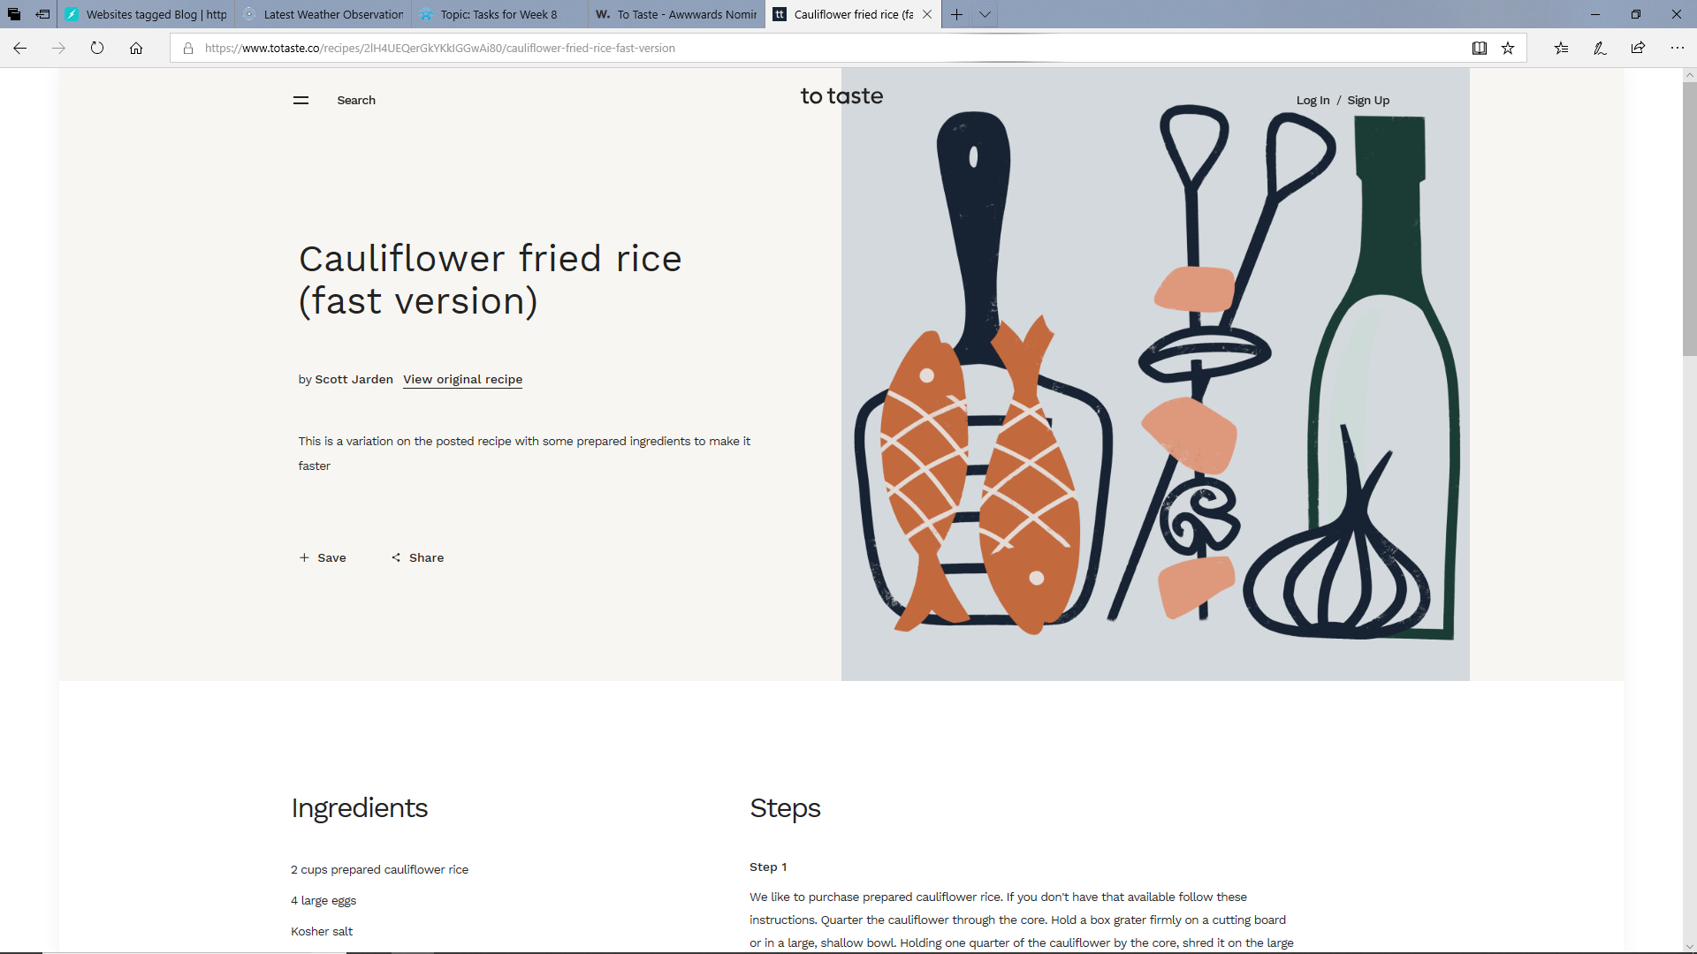

The design featured here (to taste), makes use of a hamburger menu, much like mine does, however with the exception that it is used across all 3 viewport widths, whereas mine is only used on the tablet and mobile sized viewport widths. This website also makes use of a three-column design which reduces to two columns, and then to one column, as the viewport width reduces. In that way, this website behaves similarly to that which I have created.

In the end I have decided on a design, which takes aspects of each of these three sites researched and combines them. I have used the column layout found in the first website, the desktop navigation layout in the second website and the hamburger menu layout found in the third website. I have concatenated these designs into one design which achieves the aesthetics and functionality which I had wished to achieve.

## Research performed

### Colour schemes

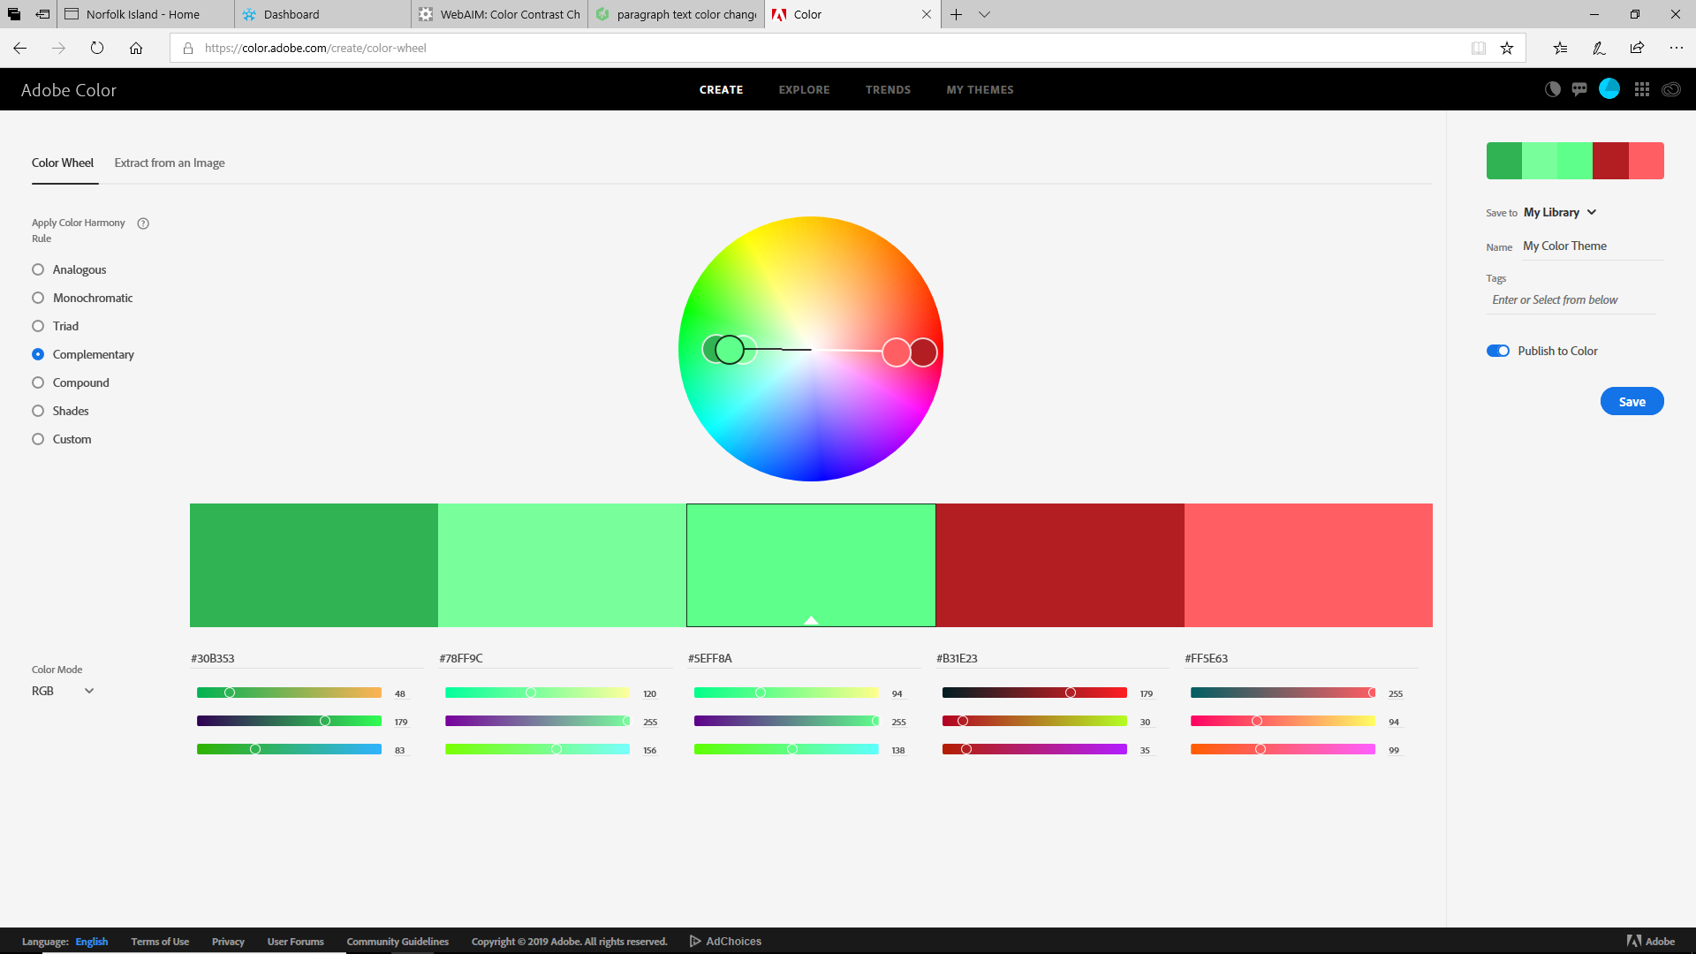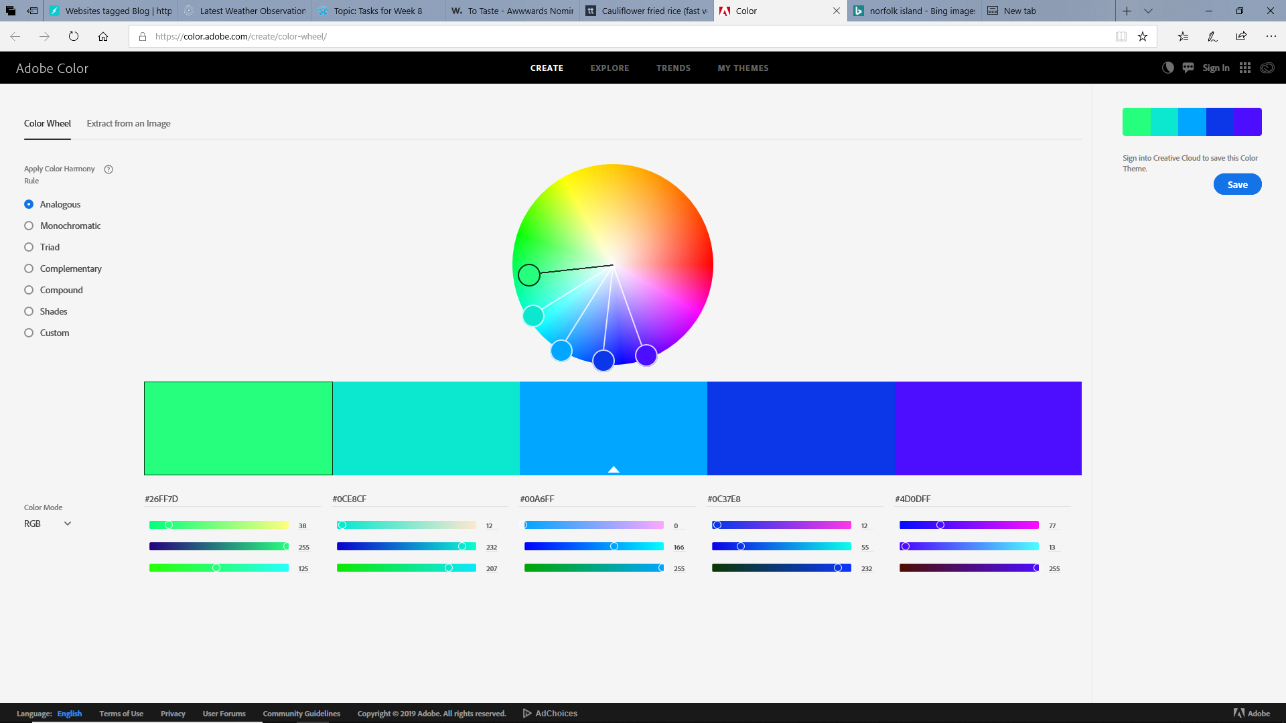

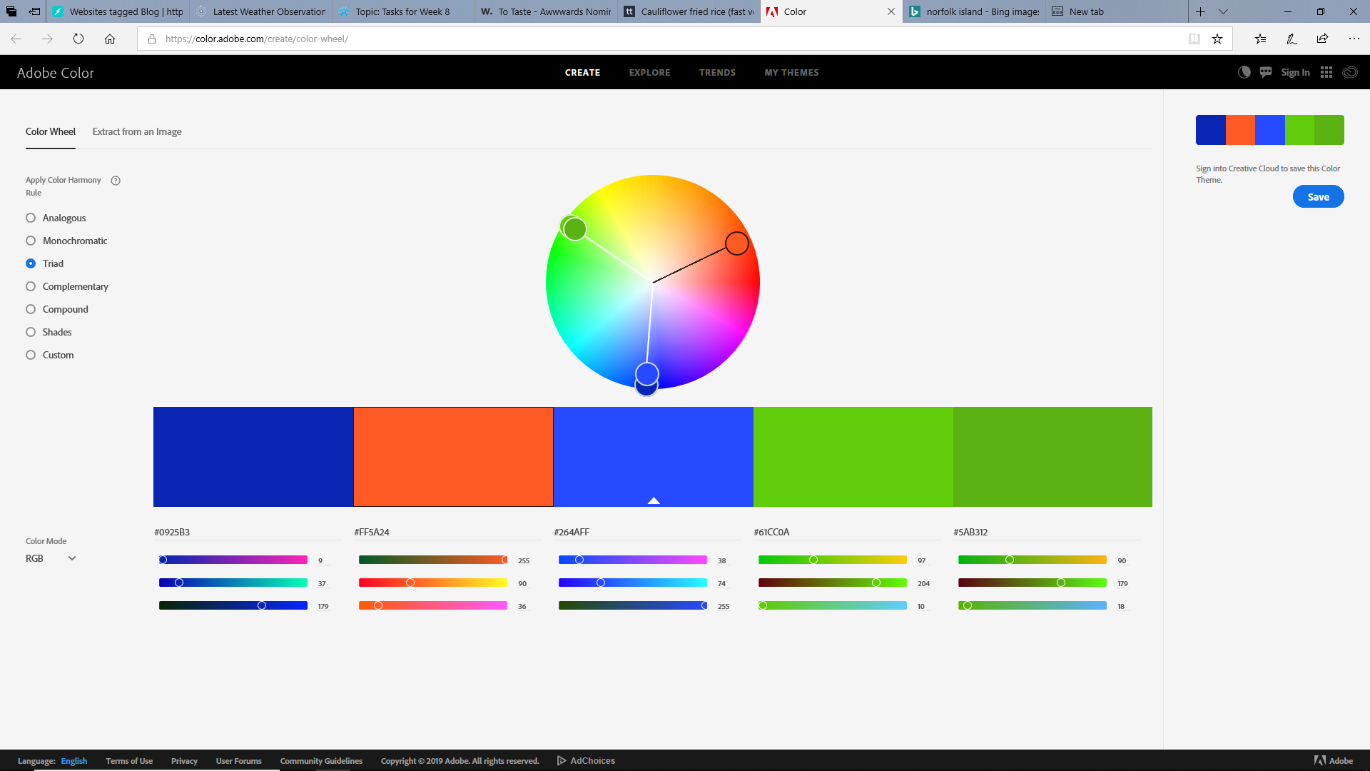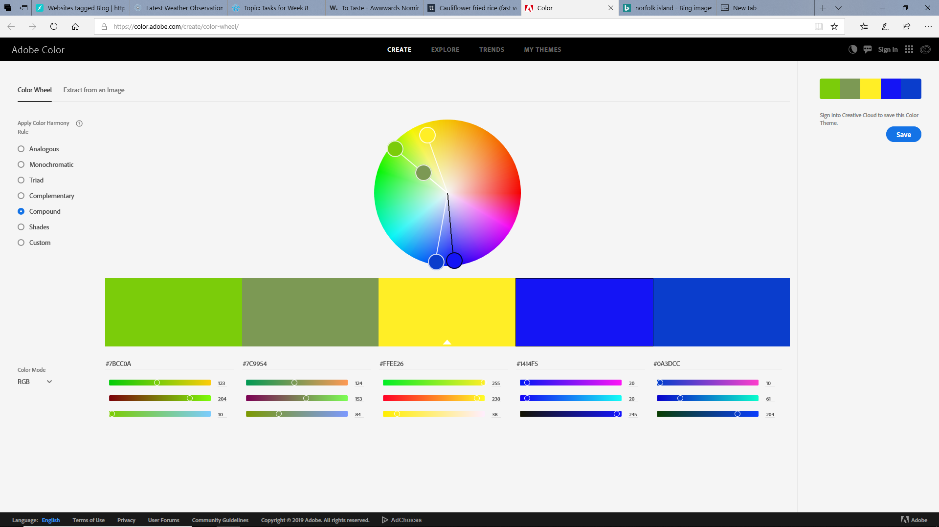

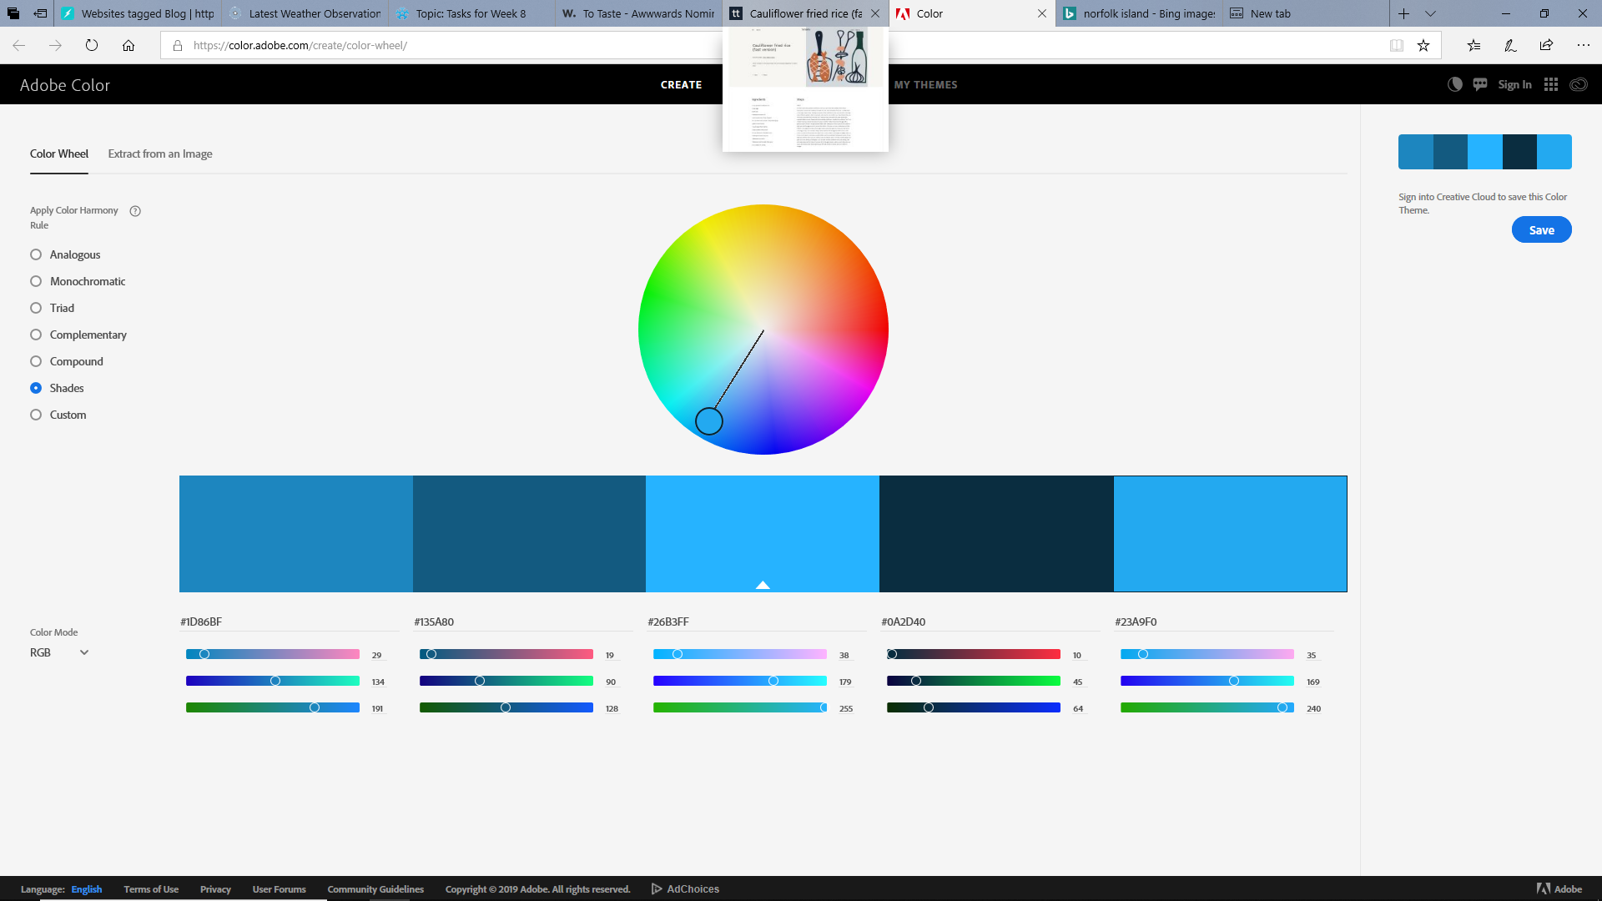

Having an idea that I wanted each section in the layout to be coloured different, I went to the colour wheel provided by adobe color and used this to help me with selecting appropriate colours to be used for the elements and containers within each page, to be defined in the CSS stylesheet. I did consider and try all of the colour schemes seen in the screenshots shown here but eventually decided on the bottom one, which contains 5 shades of blue. This being case, due to accessibility issues faced later, I was forced to change some of the shades of the colours used slightly, so that the contrast ratio of 4.5:1 would be achieved.

### Fonts

Apart from this I also performed extensive research into things such as background gradients and also some different font-family options to be used, to not be more aesthetically pleasing, but also more accessible.

I decide to use a google font called “crimson text”, which can be found here; <https://fonts.google.com/specimen/Crimson+Text>

Although it is not a sans-serif font, it appeared to me, to be significantly easier to read than many of the standard fonts commonly used, especially when reading large paragraphs, like are found within my website.

Crimson font looks like this;

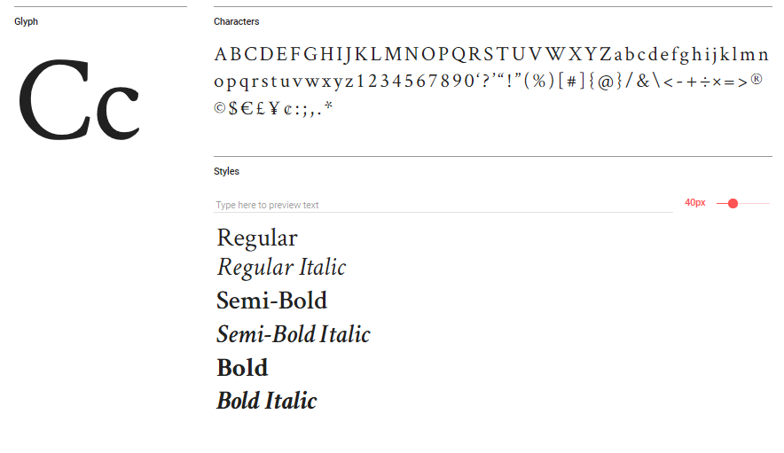

## Accessibility issues or usability issues

As is mentioned below in the accessibility audit, I encountered a few errors and warnings, most of which were regarding the use of headings. The first error was that an unordered list was being used in a “<span>”. The other was that the class was duplicated in one image, meaning the class was declared twice in one line. Other than this there were a few warnings, which mostly detailed that headings were required, where sections were being used. The other warning which I had received was that h1 headings were only to be used at the top of the page.

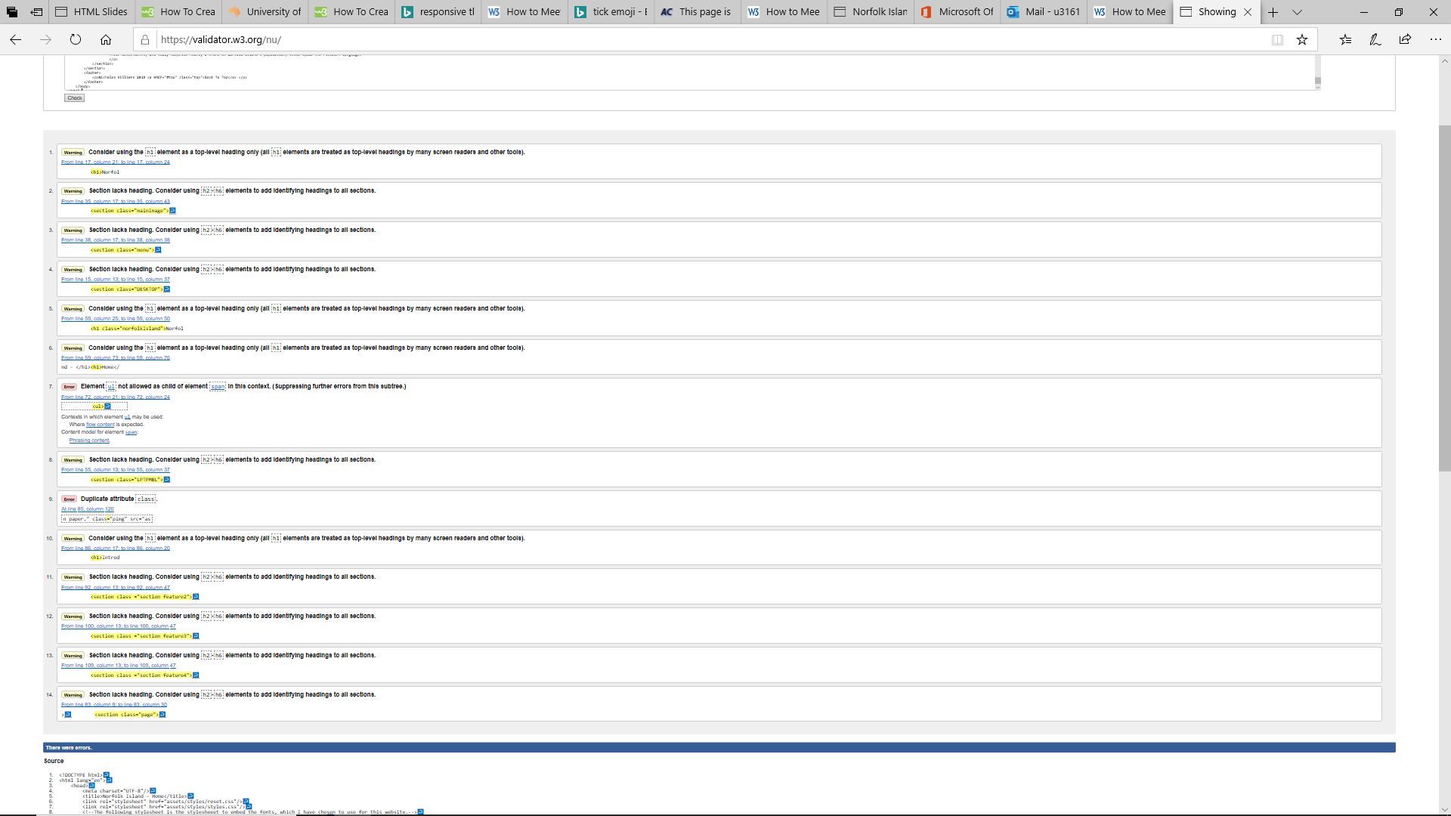

## How were they resolved?

To combat the issue of duplicated classes, I simply deleted all instances where classes were declared more than once. To eliminate the issue where an unordered list cannot be the child of a span container, I changed the semantic name of the span, so that it was now a section container. To fix the issues of sections not containing headings, I added headings to each section where headings were not used. This helps especially when using screen readers to locate content on the page more easily and without the addition of these headings, would prove difficult. Finally, unfortunately, due to the nature of the website it is not possible to suppress the warning that the h1 should only be used at the top of the website. Luckily, the h1 which this warning relates to is located at the top of the page and so does not present issues when trying to locate h1 elements, when using a screen reader to locate the top of the page.

The reviewed check now only returns one warning for each page. That is, that the “<h1>” should only be used at the top of the page. Because the h1 in question is at the top of the page, this can be disregarded.

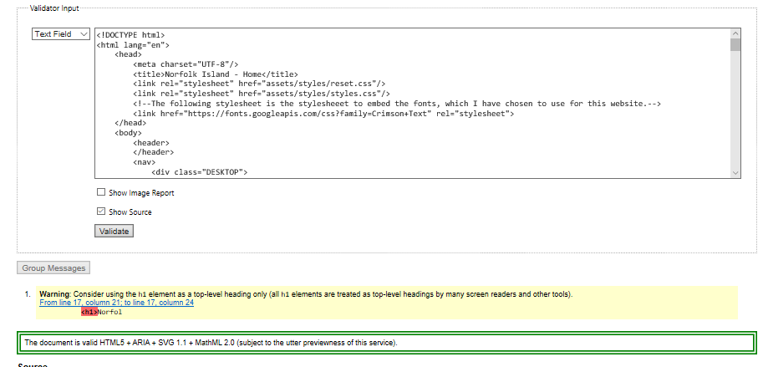

# Summary

I have thoroughly enjoyed partaking in this course. Although I am enrolled in a Bachelor of Information Technology degree, this unit was actually an elective for me. I enrolled in this unit because I enjoyed designed things and solving problems in new and different ways. Although I have already, throughout the course of my degree, completed some units which involve web design, this particular one has taught me a lot of things I did not already know. I enjoyed the structure and the progressive nature of the unit and how each module built on the last. In this assignment in particular I have learnt new CSS techniques and delved deeper into responsive design than I have previously in other units. I feel as though I have inherited a lot of knowledge and skills that I may not have thought of as being part of the web design process. I learnt the importance of planning the layout and transitions of the website, drawing them on paper, drawing them digitally and finally building the website. I have built an increased appreciation for the amount of creative thought, but also logical paternal thought that is associated with creating a website which is responsive and accessible. I have now a greater understanding of the need for accessibility and how small changes to a web site may not even be notice by an ordinary user, but to a person experiencing disability may mean the difference between being able to use the website or not. I now have a better understanding of assistive technologies which can be used to help a person with a disability use a website.

# References

Google Fonts. 2019. Google Fonts. [ONLINE] Available at: <https://fonts.google.com/specimen/Crimson+Text>. [Accessed 17 May 2019].

Site Point. 2019. 20 Distinctive Navigation Menu Designs — SitePoint. [ONLINE] Available at: <https://www.sitepoint.com/20-standout-navigation-menu-designs/>. [Accessed 17 May 2019].

WebAIM: Color Contrast Checker. 2019. WebAIM: Color Contrast Checker. [ONLINE] Available at: <https://webaim.org/resources/contrastchecker/>. [Accessed 17 May 2019].

To Taste. 2019. To Taste | A modern-day recipe box. [ONLINE] Available at: <https://www.totaste.co/>. [Accessed 17 May 2019].